**Name : Reena Qureshi**

**Reg No : 2023-BSE-052**

**Sem : V-B**

**Cloud Computing LAB 1**

**Installing VMware Workstation Pro:**

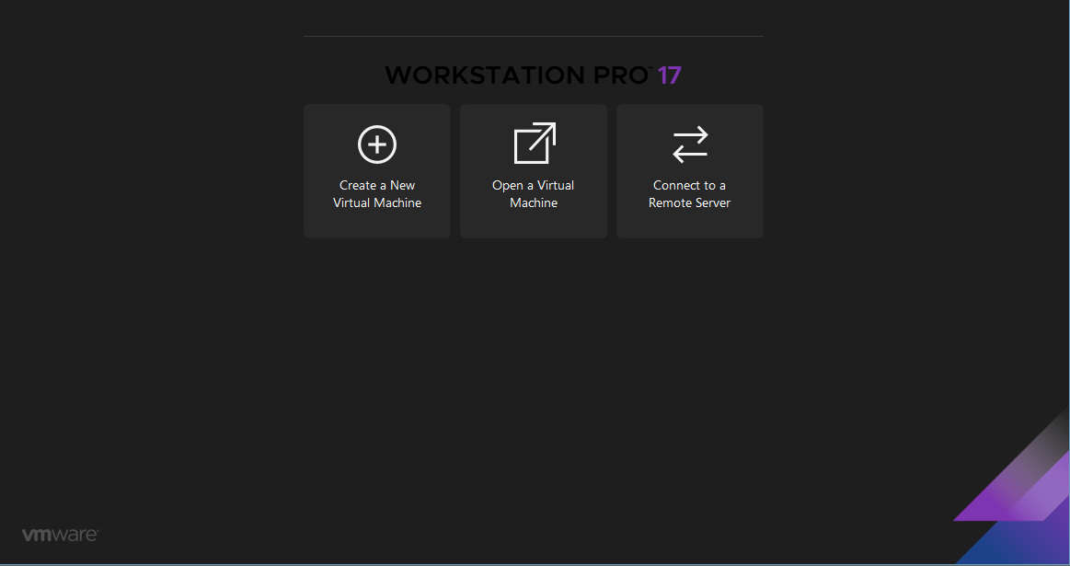

**Creating a new Virtual Machine:**

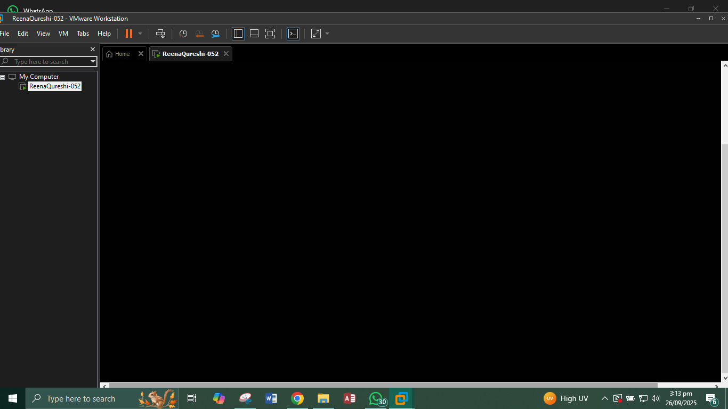

**Virtual Machine settings:**

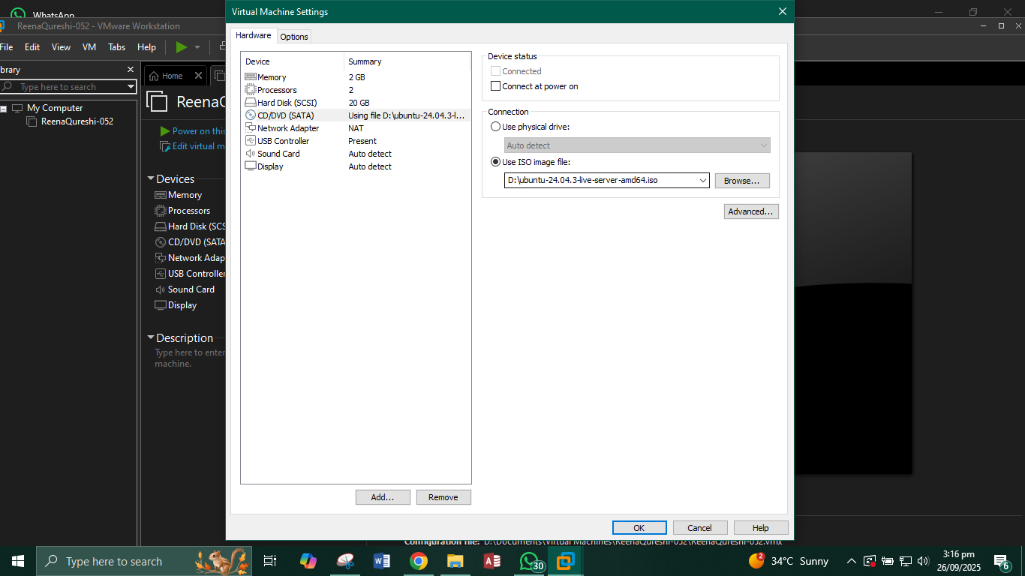

**Installation Complete:**

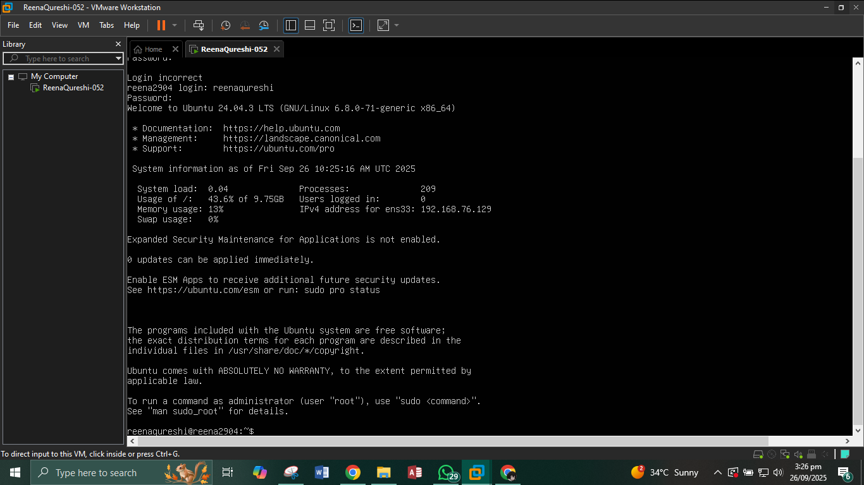

**Accessing your Ubuntu Server from Windows:**

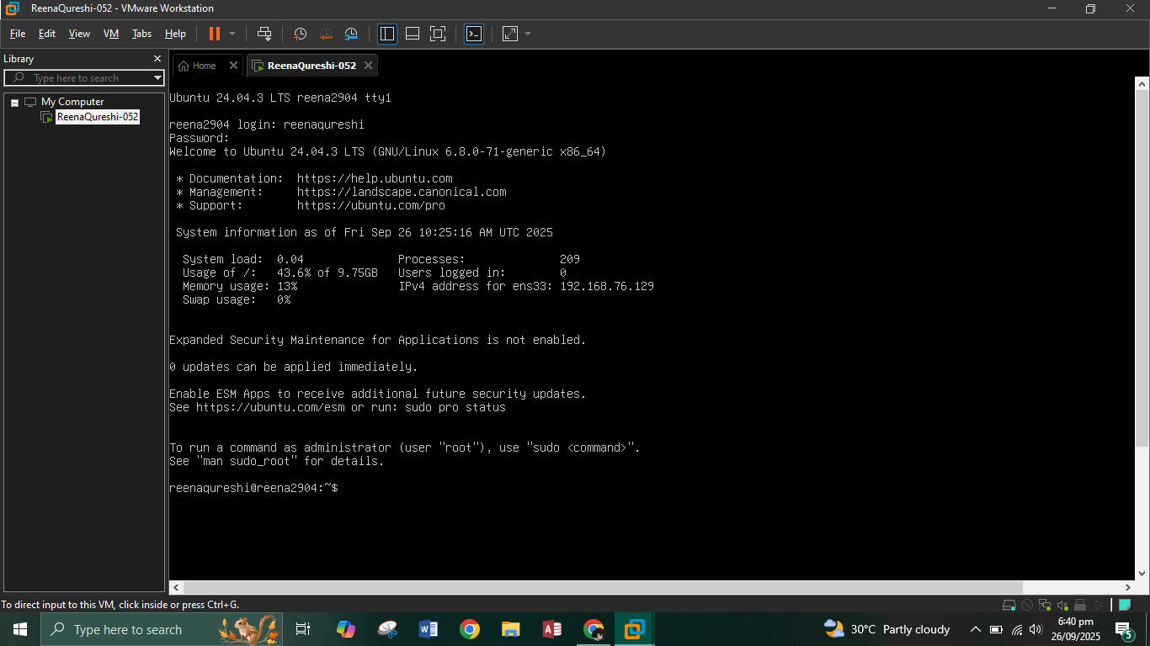

**In command prompt:**

